

UNIVERSITY OF PETROLEUM AND ENERGY STUDIES
DEHRADUN

CYBER THREAT INTELLIGENCE

LAB 5 Extract Indicators of Compromise from Security Reports

MTECH-COMPUTER SCIENCE
ENGINEERING
CYBER SECURITY AND FORENSICS

Name: Jigesh Sheoran
SAP ID: 5090025428

Objective — Learn to extract indicators of compromise (IOCs) from security reports.
Indicators of compromise (IOC) in cybersecurity refers to clues or evidence that suggest a network or system has been breached or attacked. For example, IOCs can be unusual network traffic behavior, unexpected software installations, user sign-ins from abnormal locations, and large numbers of requests for the same file.

Objective 1 : DOCGUARD

Step 1: Open https://app.docguard.io in a sandbox environment OR on a Virtual Machine. Docguard Dashboard:
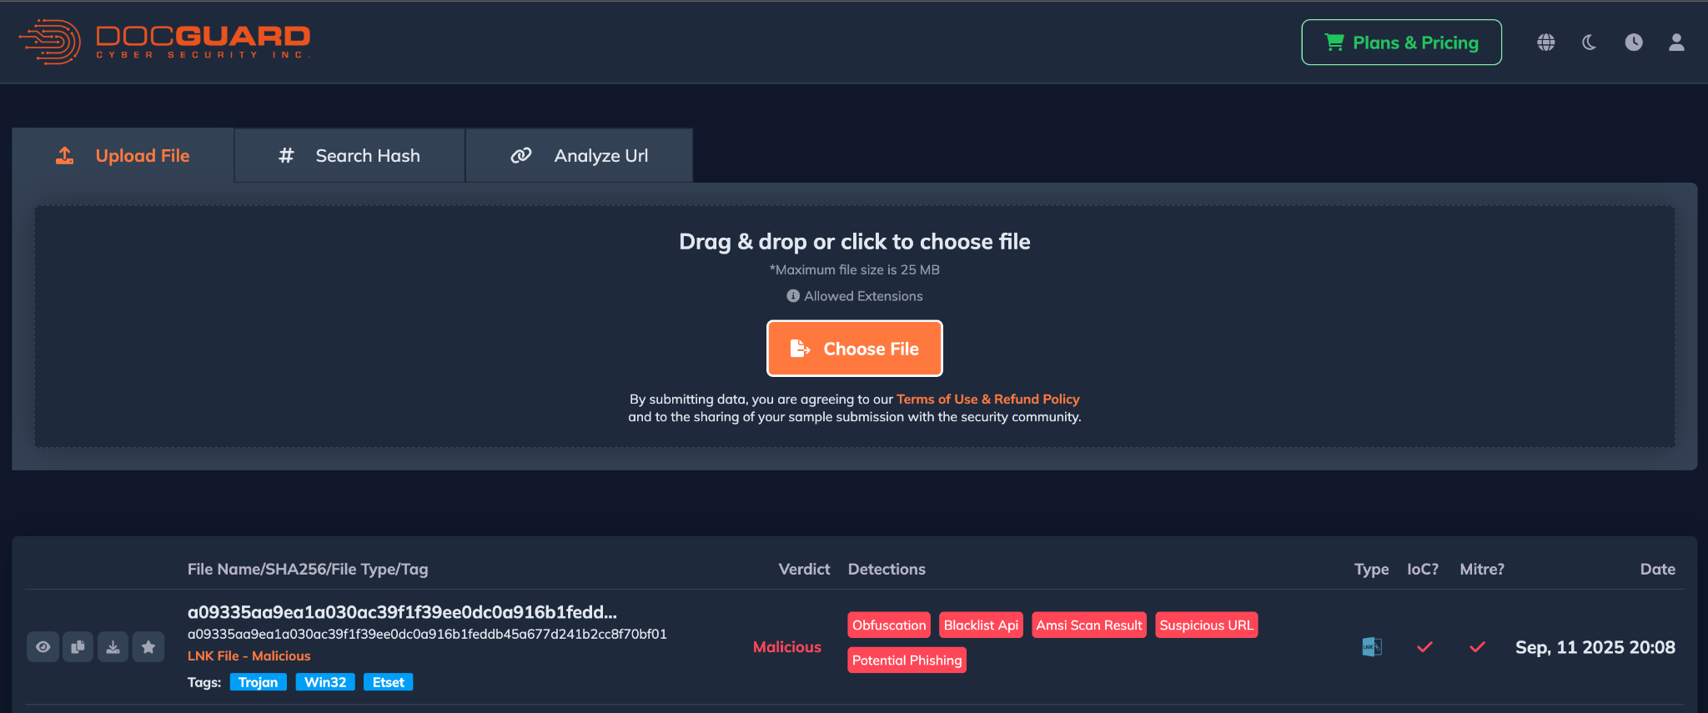

Step 2: Download malware files from https://github.com/LJ9859/Malware-Database The password for all zip files is "1337" without the quotation marks.
Malware Sample Analysis - adguardinstaller.exe
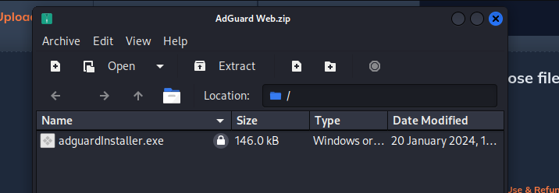

Uploading the malware sample to Doc Guard for analysis
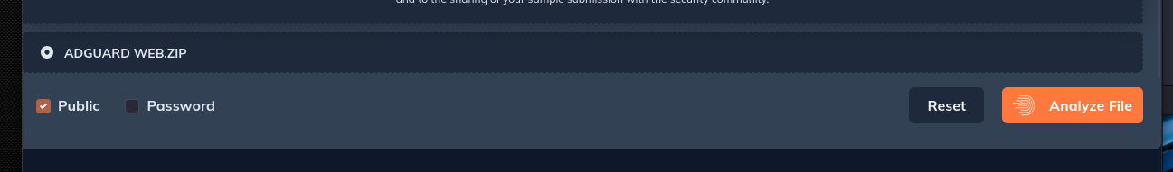
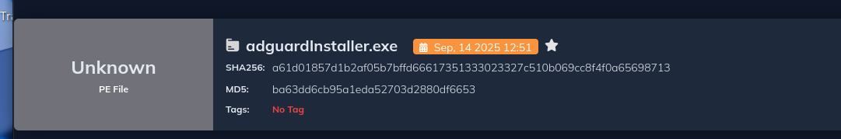
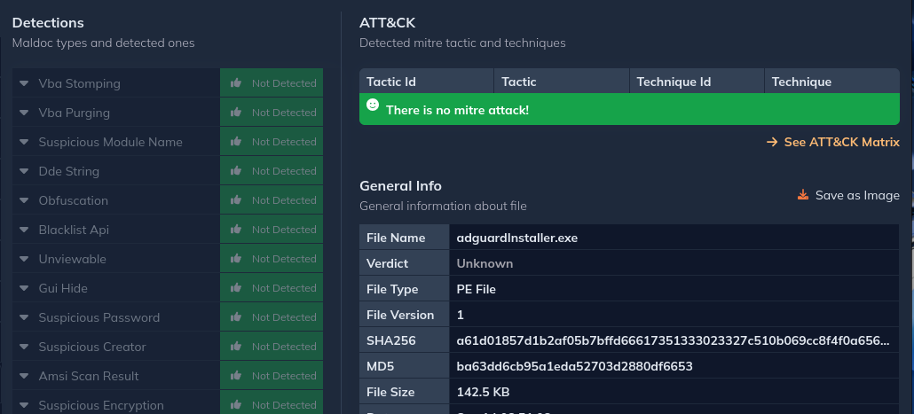
This malware sample turned out to be a false positive. No malicious activity was detected.
Let’s try another One.
Malware Sample 2 - bluestacks 10installer
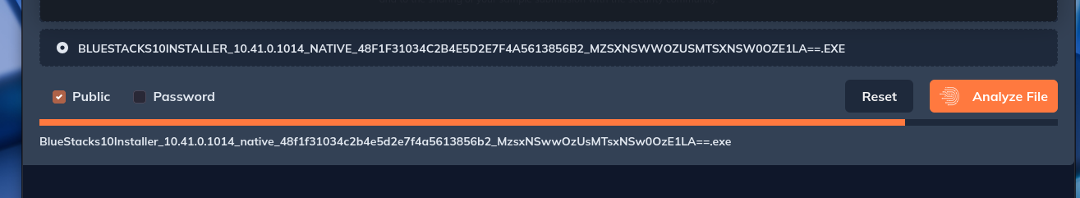
Uploading sample 2 to docguard for analysis.
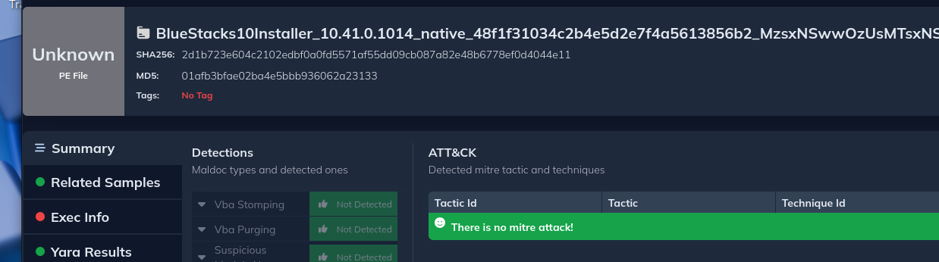
This sample also turned out to be a false positive.
Let’s try another one.
Malware Sample 3 - advanced unistaller13
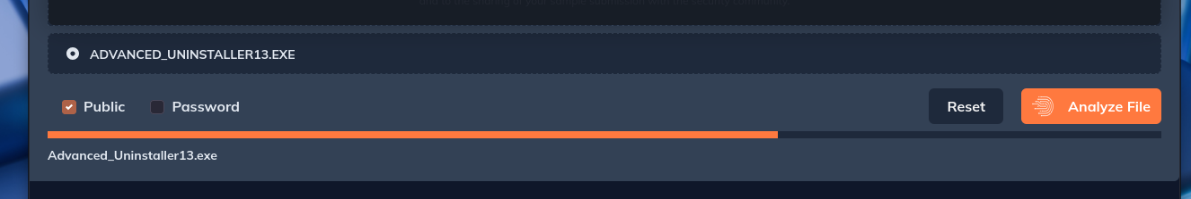
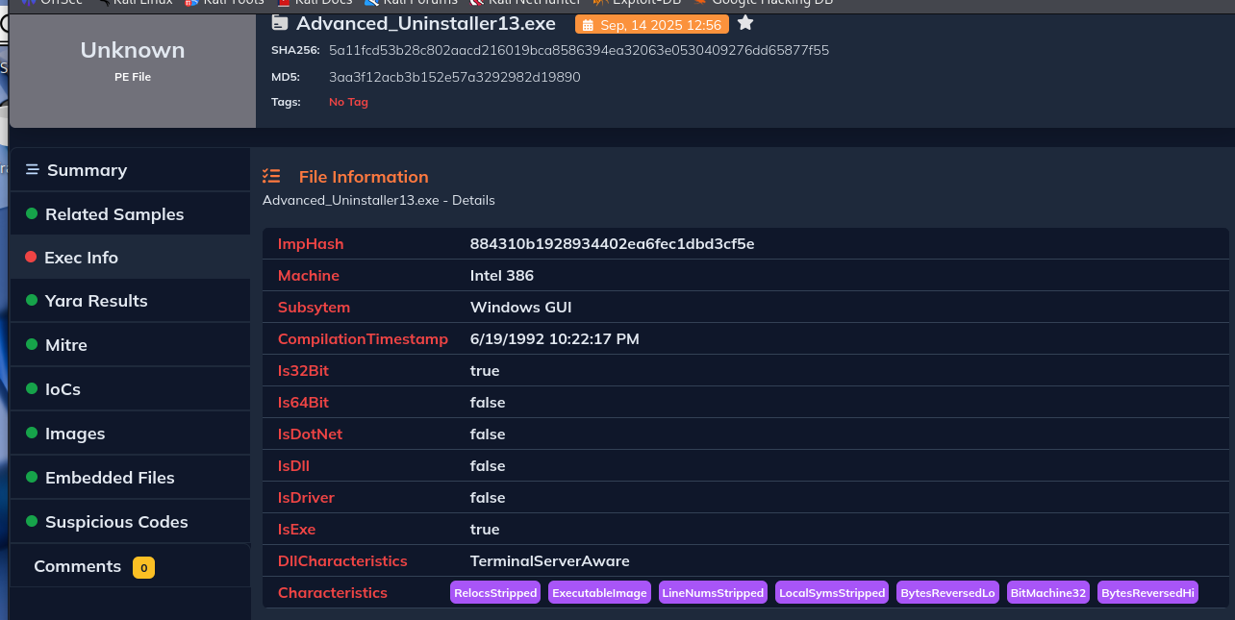
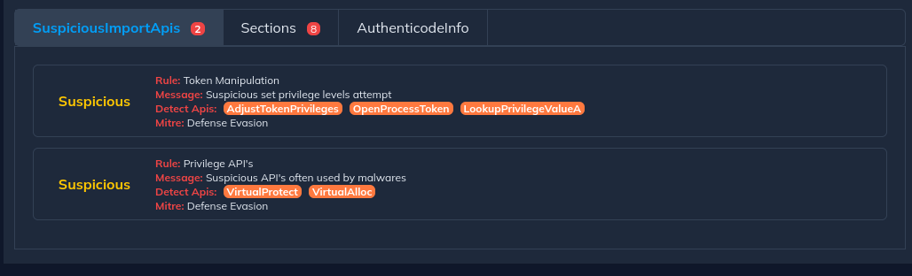
I downloaded this malware sample named Advanced Uninstaller 13 from GitHub and analyzed it using DocGuard. The tool flagged suspicious API imports linked with MITRE ATT&CK Defense Evasion techniques.
- First, I noticed token manipulation APIs like AdjustTokenPrivileges, OpenProcessToken, and LookupPrivilegeValueA. These are typically abused by malware to elevate privileges and bypass restrictions.
- Next, the sample also used memory manipulation APIs such as VirtualProtect and VirtualAlloc. These are commonly leveraged to inject malicious code into memory or unpack payloads at runtime.
My key learning from this exercise is that even if a program looks normal, its imported APIs can reveal malicious intent. Privilege escalation and memory modification are clear signs of defense evasion techniques.
Step 6: Copy malicious file/malware Hashes from https://github.com/bitdefender/malware-ioc/blob/master/metamorfo_malware/samples.hash
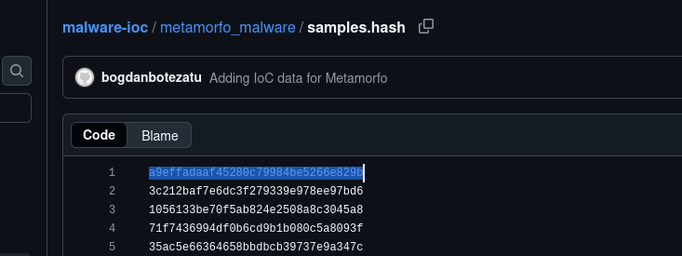
Step 7: Paste into Docguard and analyze
Hash Sample 1
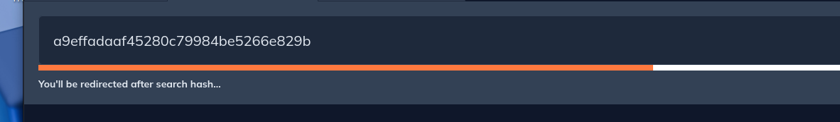

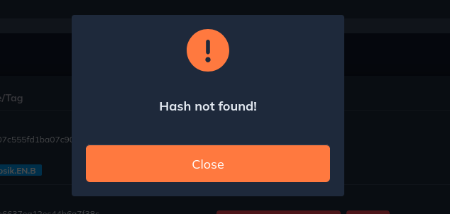
Hash Sample 2
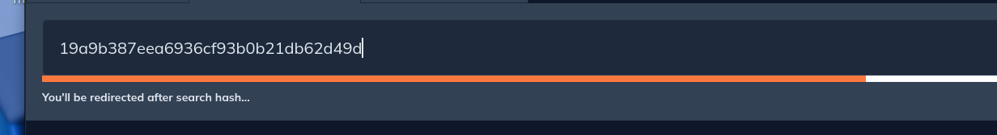
Step 8: Study the Hash summary reported by Docguard.
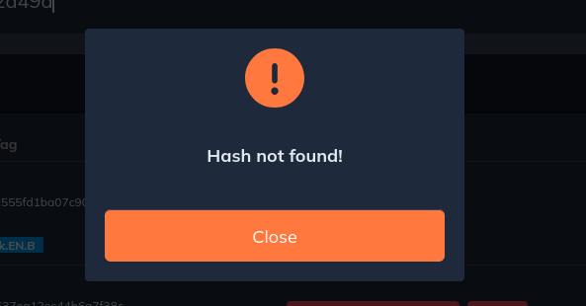
I tested hash samples from the GitHub repo Bitdefender Malware IOC – Metamorfo Malware, but none of them were detected on either DocGuard or VirusTotal.

Step 9: Copy URL from https://www.kaggle.com/datasets/sid321axn/malicious-urls-dataset, paste the URL into Docguard and analyze.
Instead i used the source: Bitdefender Malware IOC – Metamorfo Malware
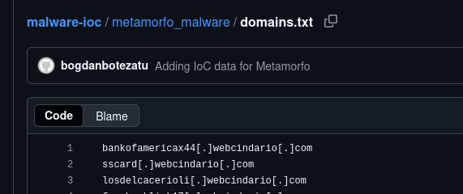
Step 10: Analyze the following domains on both platforms DOCGuard and VirusTotal.
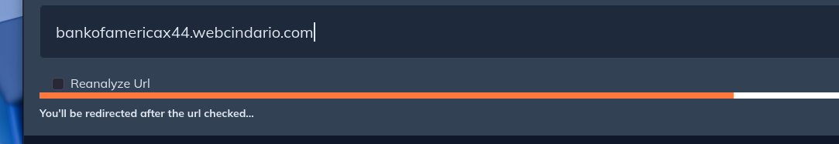
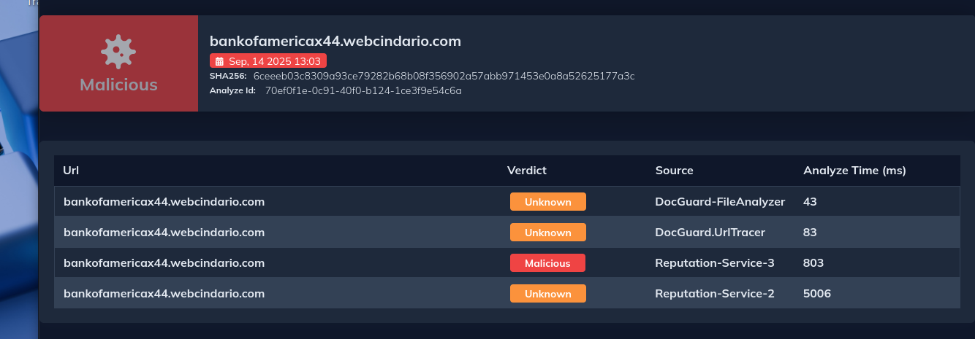
Conclusion from DOCGuard:
The domain bankofamericax44.webcindario.com was flagged as malicious during analysis on DocGuard.
While some modules (FileAnalyzer, URLTracer, Reputation-Service-2) returned an unknown verdict, Reputation-Service-3 positively classified it as malicious. This mixed detection highlights that reputation-based services can provide stronger context when file or URL analyzers alone do not have enough data.
We should always validate IOCs across multiple engines and sources, since partial or "unknown" verdicts in automated tools can still indicate malicious intent when cross-referenced with reputation intelligence.
Analysis from VirusTotal :
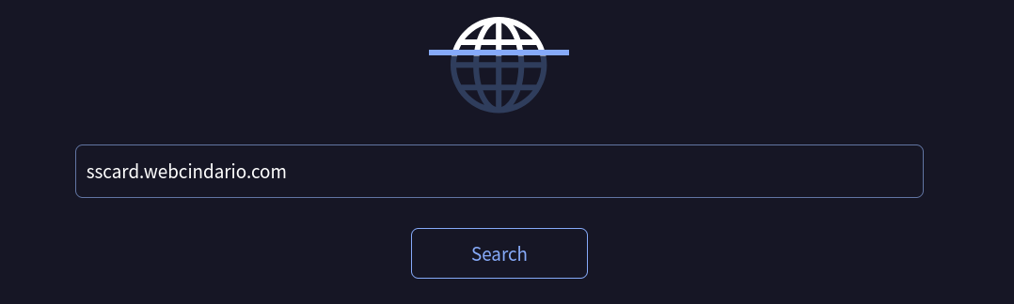
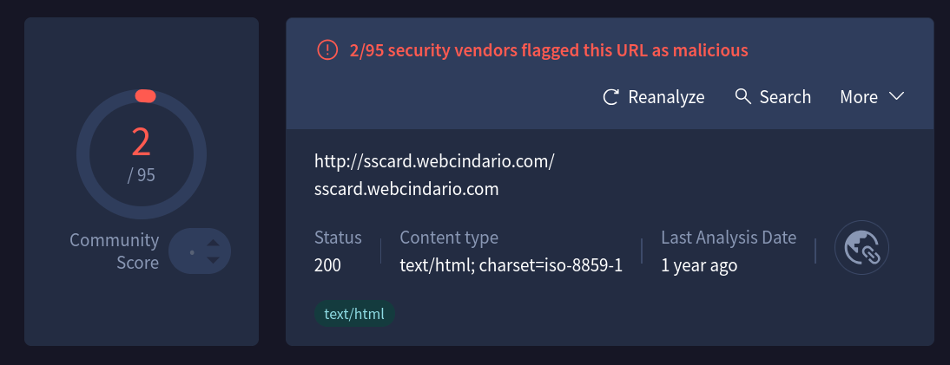
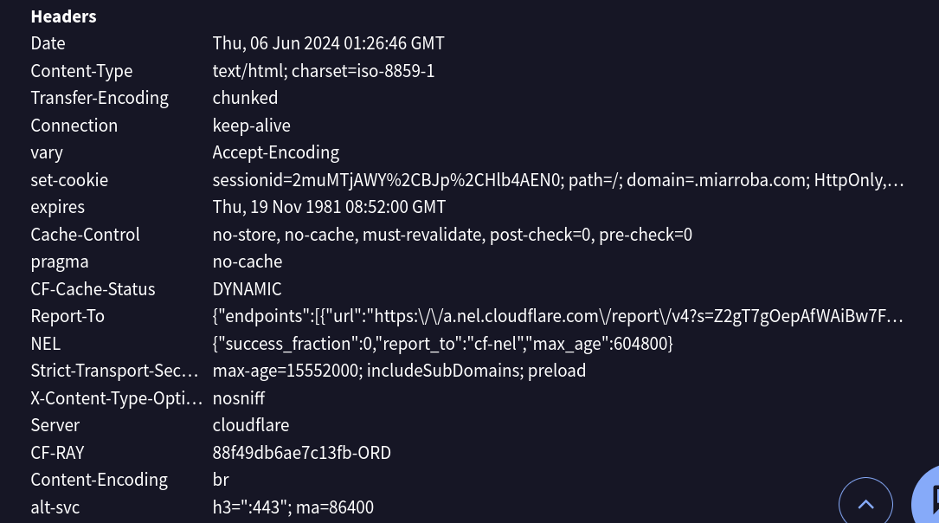

Learning
- Even if only a few vendors flag a domain, it should still be considered an IOC because attackers often rotate infrastructure to avoid mass detection.
- Old domains on free hosting services (like webcindario.com) are often recycled for phishing, malware delivery, or carding campaigns.
- Cross-checking with other CTI platforms (ThreatMiner, URLhaus, AlienVault OTX) is important when VirusTotal results are limited.
- Suspicious cookies and session management can be early red flags of phishing kits or credential-stealer pages.

2. AlienVault Open Threat Exchange (OTX)
This is a community-driven threat intelligence platform that allows searching for IOCs like IPs, domains, URLs, and hashes. You can also contribute your own findings to the platform.
Step 1: Use https://otx.alienvault.com to create a free account, access the dashboard.
Step 2: Check last 24 hours malware families
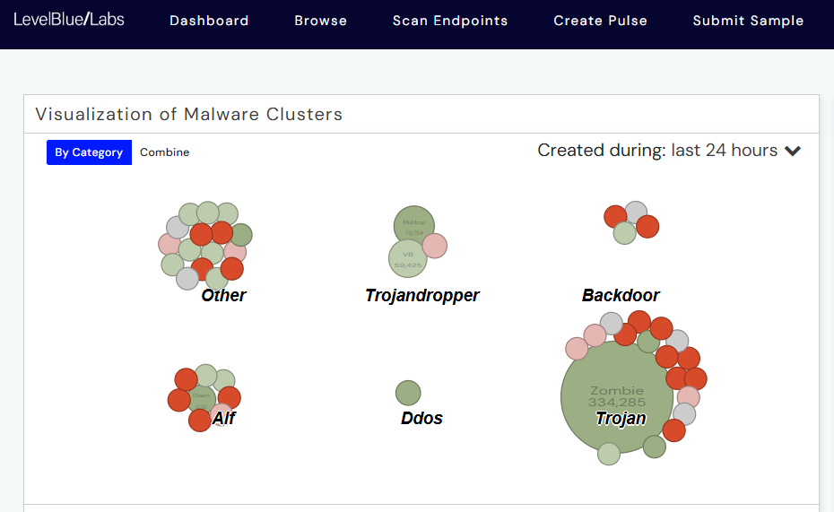
Step 3: Browse to learn about Malware trends / pulses, users, groups, IoCs, Malware families.
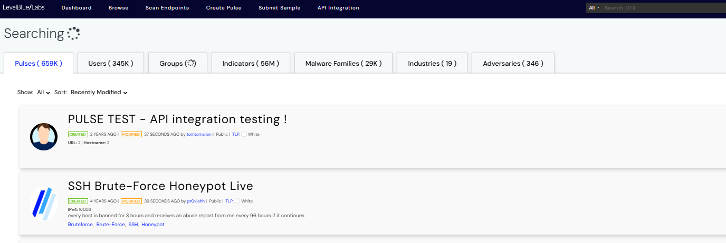
Step 4: Submit a malware sample and view its summary
Source: Malware-Database/Chrome-Extensions/Lukall-Safe Search Engine.zip
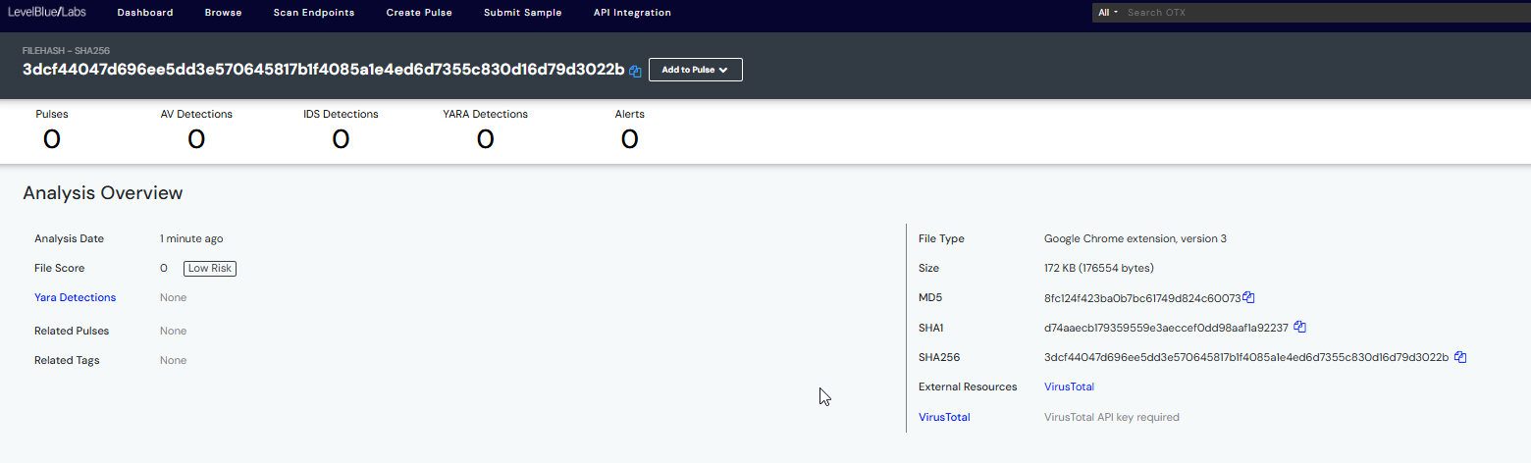
Observation:
I uploaded a suspicious file hash (3dcf44047d696ee5dd3e570645817b1f4085a1e4ed6d7355c830d16d79d3022b) into LevelBlue OTX for analysis.
- The file was identified as a Google Chrome extension (version 3) with a size of ~172 KB.
- No AV detections, IDS detections, or YARA rules matched the file, meaning it is currently classified as low risk.
- There were no related pulses, tags, or reports, which suggests this sample has not yet been reported widely in the community.

Sample 2 : PS - CSV text
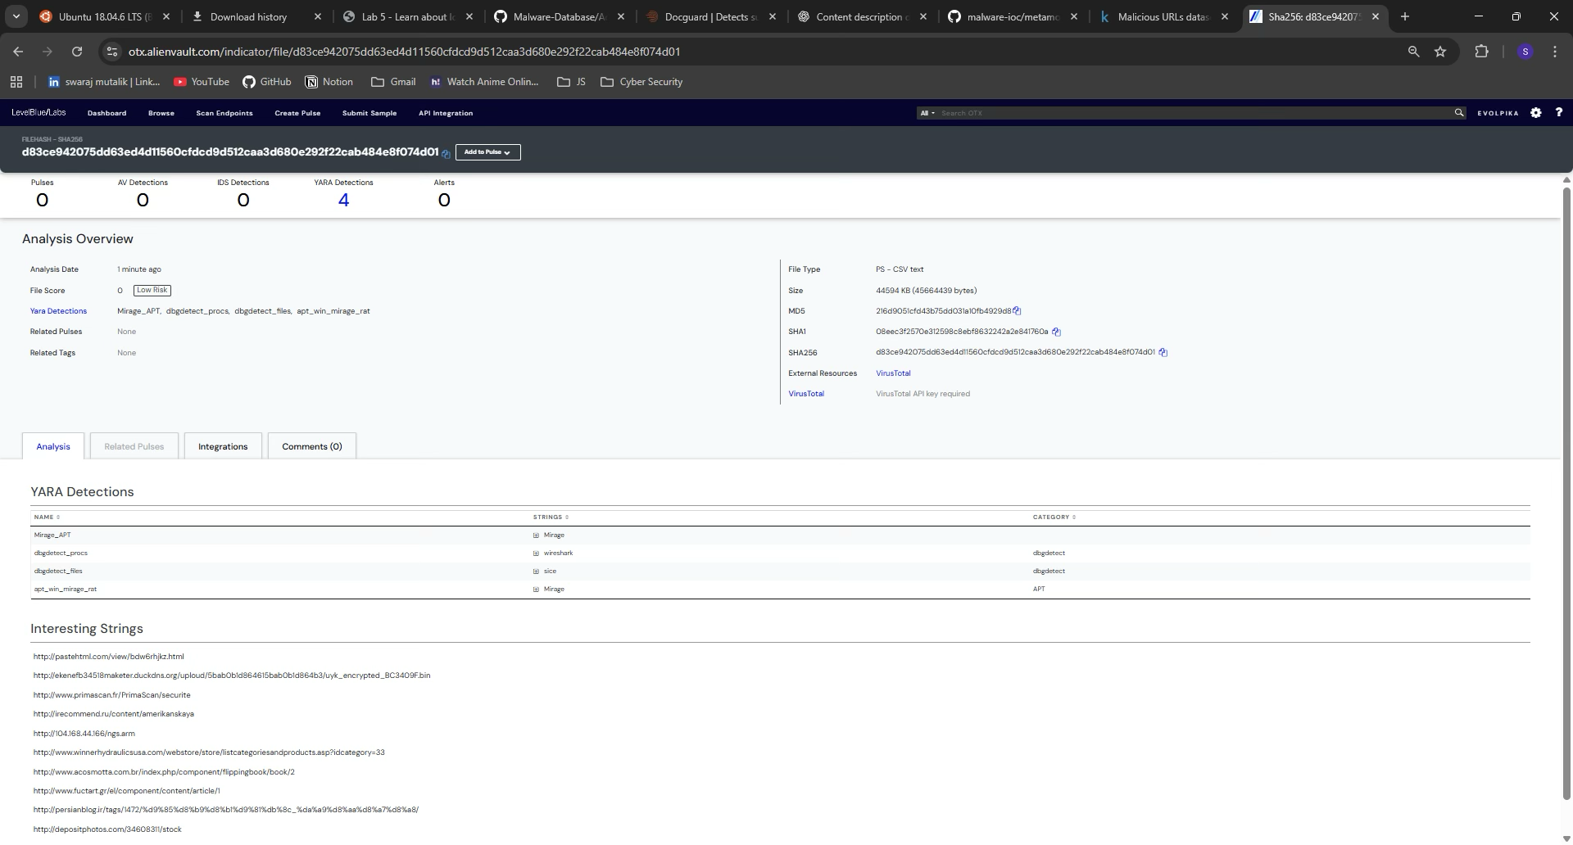
- MD5: 21a690d456fa5b36d0ab10fa0923d8
- SHA1: 08eec9f670b512698e8ef86322242ba7e81760a
- SHA256: d83ce942075dd63ed4d11560fcdd9d512caa36d80e292f2cab484e8f074d401
- File Score: 0 (Low Risk)
- The file triggered four YARA detections, which indicate potential threat associations:
  - Mirage_APT → Related to Mirage Advanced Persistent Threat activity.
  - dbgdetect_procs → Associated with process detection and debugging behavior.
  - dbgdetect_files → Linked to suspicious file-level debugging detection.
  - apt_win_mirage_rat → Suggests correlation with the Mirage Remote Access Trojan (RAT) used by APT actors.
The analyzed CSV file (45 MB) was rated as Low Risk with no antivirus or IDS detections, the presence of four YARA rule matches tied to the Mirage APT group cannot be ignored.

3. PulseDive
Target 1 : upes.ac.in
Aggregates data from various sources to provide insights on IPs, domains, URLs, and malware samples. It offers free basic features and paid plans for additional functionalities.
Step 1: Enter a Domain name to check on https://pulsedive.com/ioc/

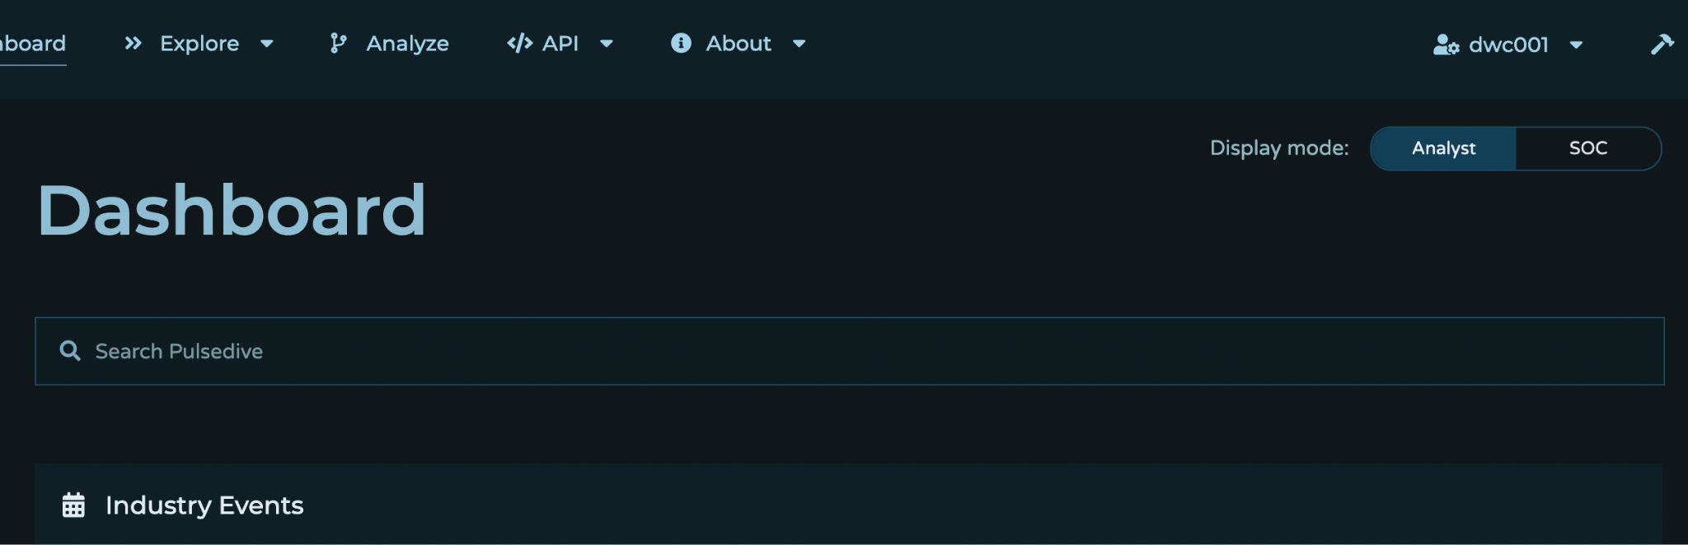

Analyzing www.upes.ac.in

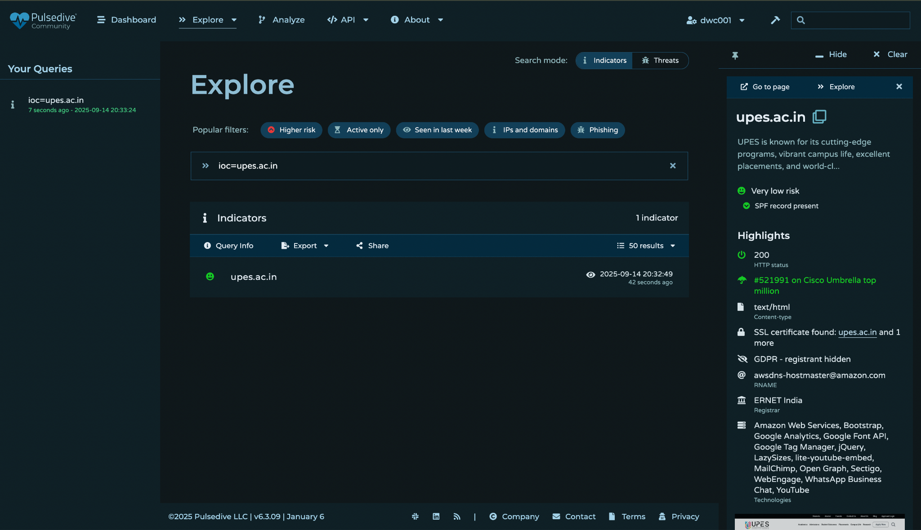
- Risk Level:
Marked as Very Low Risk.
- HTTP Status:
  - 200 OK → Website is live and responding.
- Reputation/Visibility:
  - Listed in Cisco Umbrella Top Million (#521991) → Suggests legitimate and frequently accessed domain.
The domain upes.ac.in (University of Petroleum and Energy Studies, India) is categorized as very low risk with no active malicious indicators on Pulsedive.
Security practices like SPF and SSL were found present.
No reporting is needed for this domain on abuse platforms — it does not appear malicious or suspicious.
Target 2 : IP/147.45.178.94
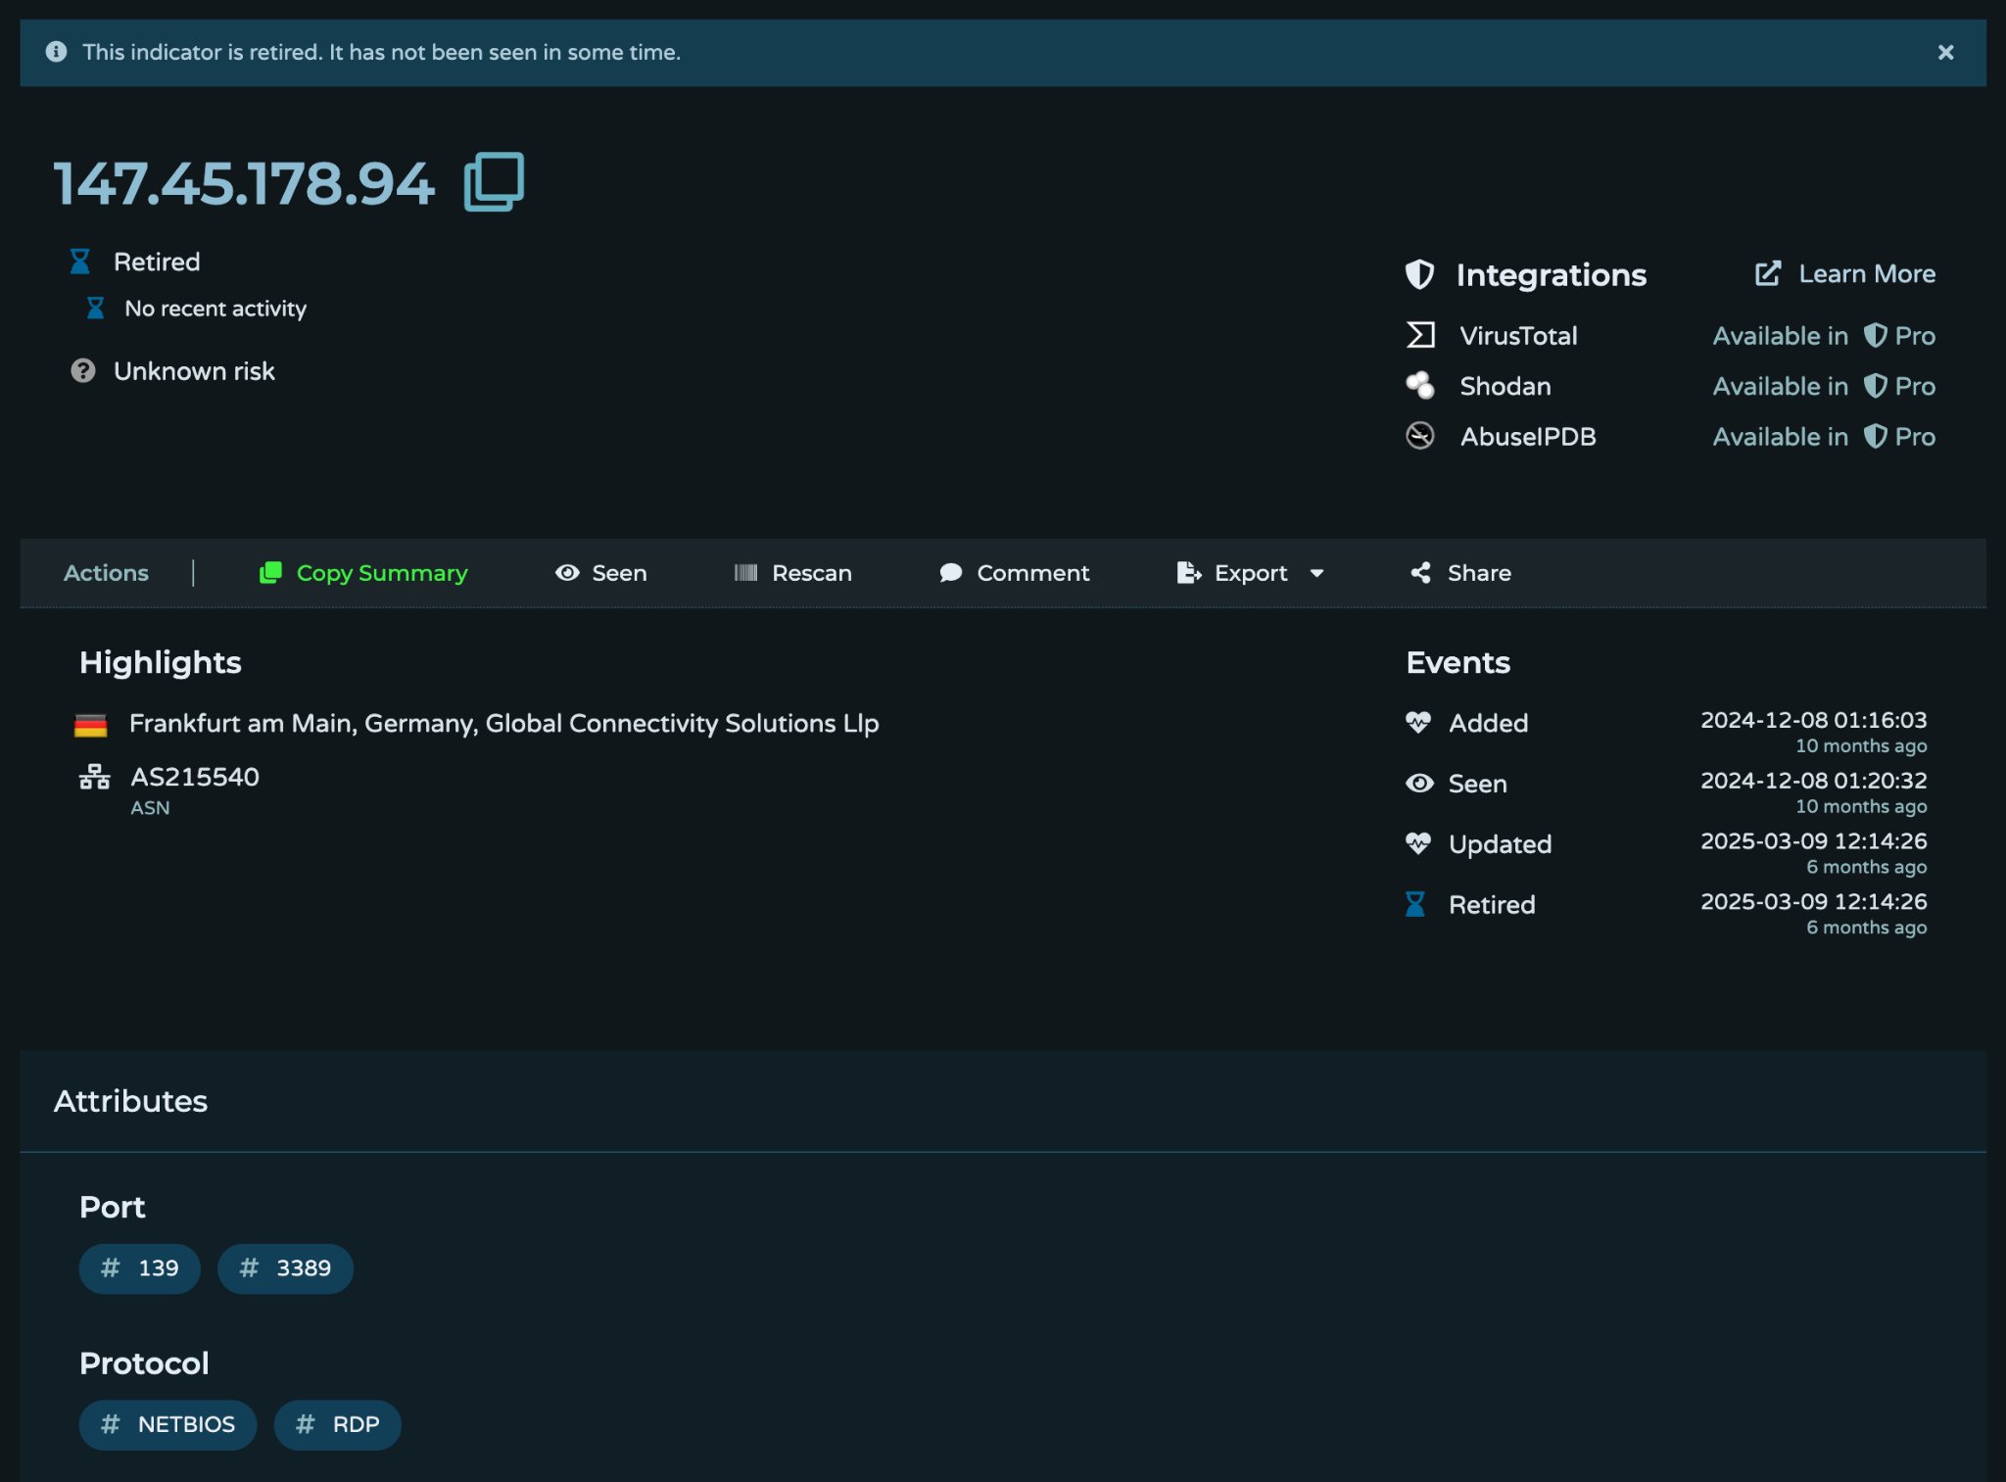

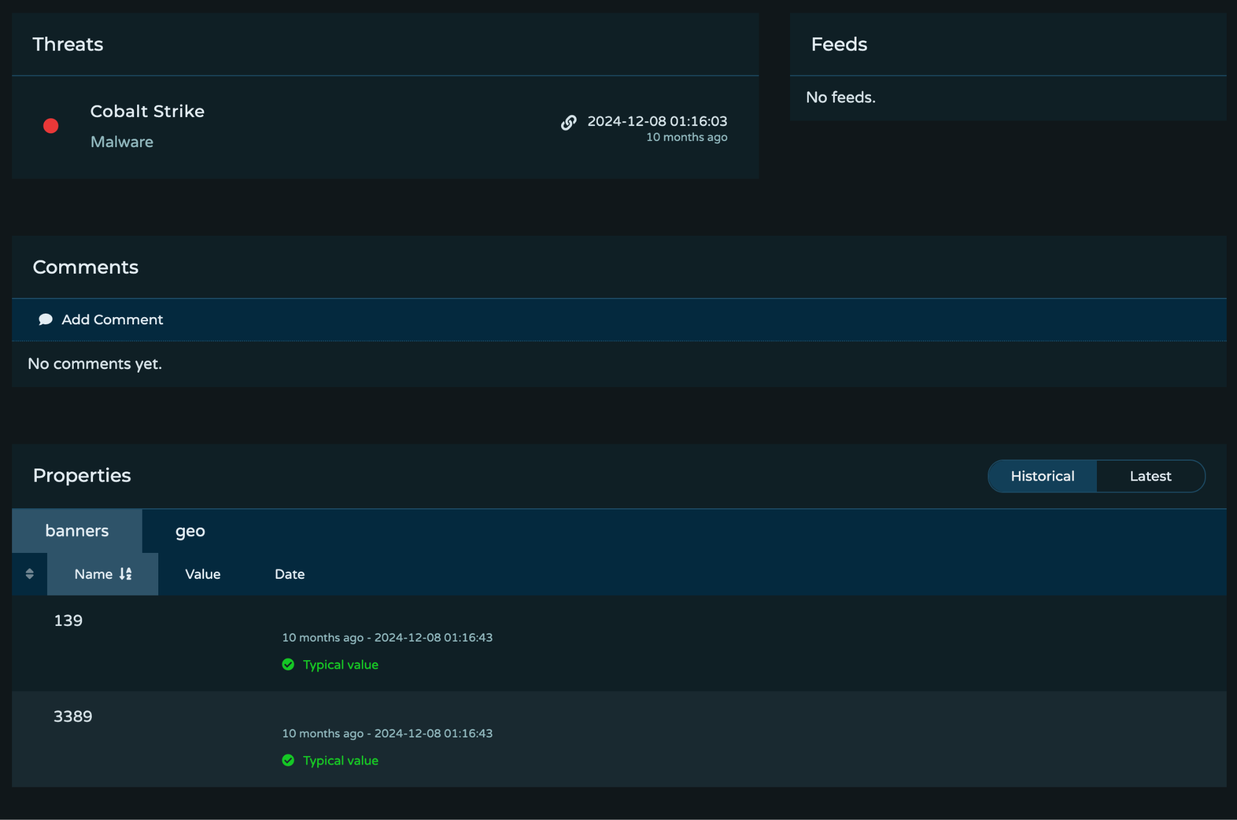
The IP 147.45.178.94 was earlier associated with Cobalt Strike malware activity, specifically showing RDP (3389) and NetBIOS (139) exposure.
However:
- It is now retired and shows no recent activity.
- Risk is currently listed as unknown (meaning it may no longer be actively malicious, but retains historical significance).
Since it was tied to Cobalt Strike, it should still be treated as a potential IOC in further investigations.

—-------------------------------END OF DOCUMENT -------------------------------------

